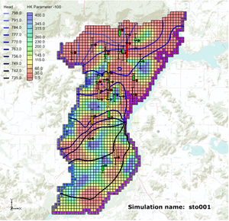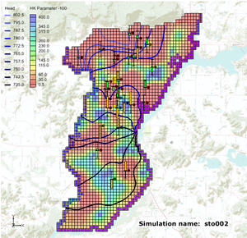

GMS 10.9

GMS 10.9 Tutorial

***MODFLOW – Stochastic Modeling, PEST Null Space Monte Carlo I***

Use PEST to create multiple calibrated MODFLOW simulations

Objectives

The PEST Null Space Monte Carlo modeling option for MODFLOW is described. Null Space Monte Carlo is used to create multiple calibrated MODFLOW models.

Time

* 30–40 minutes

Required Components

* GMS Core
* MODFLOW Interface
* PEST
* Parallel PEST
* Stochastic & T-PROGS

Prerequisite Tutorials

* MODFLOW – Advanced PEST

|  |
| --- |
| 1 Introduction 2  2 Getting Started 3  2.1 Importing the Project 4  3 Using the Null Space Monte Carlo Method 5  3.1 The MODFLOW Run Options 5  3.2 Parameter Options 6  3.3 Saving the Project and Running PEST 6  3.4 Importing and Viewing the MODFLOW Solutions 8  4 Conclusion 12  5 Further Reading 13 |

# Introduction

GMS supports three methods for performing stochastic simulations: PEST Null Space Monte Carlo, parameter randomization, and indicator simulations. This tutorial will introduce the PEST Null Space Monte Carlo method. The latter approaches are described in separate tutorials.

This tutorial borrows from John Doherty’s *PEST Workshop* document.[1] All credit for the approach of quantifying model uncertainty goes to Doherty and his co-authors.

There is always a significant amount of uncertainty associated with a groundwater model. Uncertainty can be associated with the conceptual model, field data, or input parameters of the model. Some model parameters—such as hydraulic conductivity—are particularly prone to uncertainty. This risk can be reduced by calibrating a model to observation data (monitoring wells, stream flows, etc.). However, a well-calibrated model can still harbor uncertainty.

The challenge with a groundwater model is to explore the uncertainty while maintaining a calibrated model (e.g., a good fit with field-measured values). The creation of model input parameters that respect calibration constraints is time-consuming since a parameter estimation exercise is needed for each new set of parameters. Two tools provided with PEST reduce the amount of time required to perform calibration-constrained Monte Carlo analysis of a groundwater model.

The first tool is the use of SVD-Assist in the calibration process. The second tool is the pre-calibration null space[2] projection. This projection expresses the differences between the stochastic parameter fields and the simplified calibration parameter field specified to calibrate the model. By using both of these utilities, it is possible to obtain parameter sets that respect the stochastic variability of the subsurface and the field-measured values. This is accomplished with a handful of runs per realization.

This tutorial starts with a calibrated MODFLOW model used as a starting point to create additional calibrated models with different hydraulic conductivity (HK). Pilot points have been used to estimate HK fields. PEST—running in SVD-Assist mode—was used to calibrate the model.

Figure 1 shows a groundwater model for an unconfined alluvial aquifer in Wisconsin, USA. The alluvium is highly variable in terms of hydraulic conductivity. In some areas, it is composed of well-sorted gravels with high conductivity, while in other areas it is composed of sandy silts with low conductivity. While the location and description of the model area are accurate, the observation wells used in this exercise are not field-measured values.

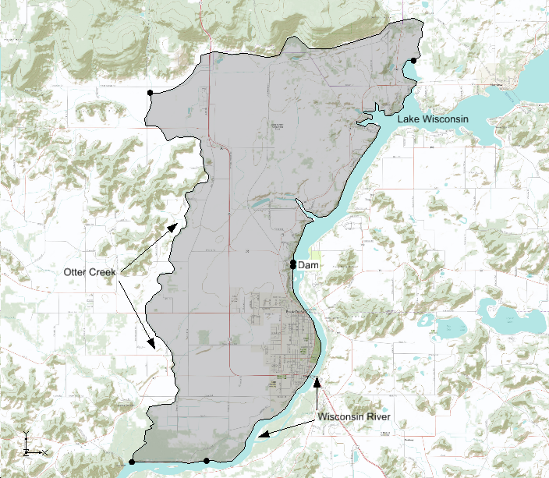

Figure 1 Study area

The model is bounded on the east by Lake Wisconsin and on the south by the Wisconsin River. A stream (Otter Creek) is used as the western boundary. Based on observed heads, it is assumed that a significant amount of recharge occurs along the northern boundary. The aquifer becomes very thin when approaching the northern and western boundaries.

This tutorial discusses and demonstrates opening a MODFLOW model calibrated using PEST with SVD-Assist, setting up a Null Space Monte Carlo model run, and running Parallel PEST with SVD-Assist and Null Space parameter projection for multiple model runs.

# Getting Started

Do the following to get started:

1. If necessary, launch GMS.
2. If GMS is already running, select *File |* **New** to ensure that the program settings are restored to their default state.

## Importing the Project

Import a project containing the MODFLOW solution:

1. Click **Open** File:Open Macro.svg to bring up the *Open* dialog.
2. Select “Project Files (*.gpr) from the *Files of type* drop-down.
3. Browse to the *sto_pest_nsmc_I\sto_pest_nsmc_I* directory and select “start.gpr”.
4. Click **Open** to import the project and exit the *Open* dialog.

A one layer MODFLOW model with observation wells should appear (Figure 2).

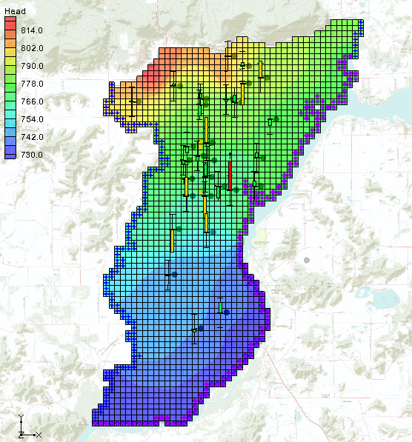

Figure 2 Calibrated MODFLOW model

1. Fully expand the “File:3D Grid Folder.svg 3D Grid Data” folder in the Project Explorer and all folders under it.
2. Right-click on the “File:Generic Folder Locked.svg start (MODFLOW)” folder and select **Properties…** to bring up the *Properties* dialog.

This dialog allows for reviewing the error associated with the model. This model is fairly well calibrated. Notice that *Root Mean Squared Residual (Head)* has a value of about “1.33”, and *Sum of Squared Weighted Residual (Head+Flow)* has a value of about “197.56”. Most of the computed heads at the observation wells are within acceptable limits (green targets); several of the observations wells have computed heads just outside of acceptable limits (yellow targets) and one observation well has significant error (red target).

1. Click **OK** to exit the *Properties* dialog.
2. Select the “File:Dataset Cells Active.svg HK Parameter -100” dataset in the Project Explorer.

The Main Graphics Window should appear similar to Figure 3.

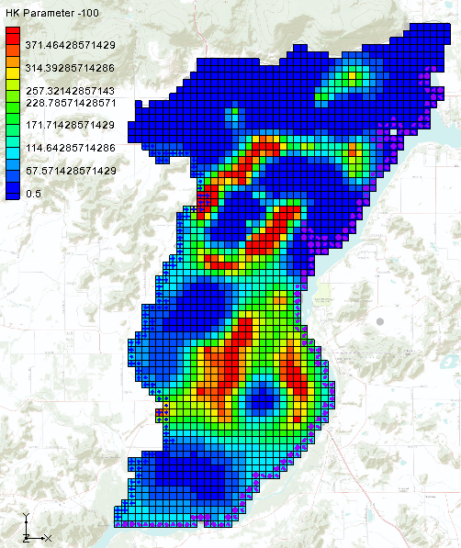

Figure 3 Hydraulic conductivity (HK) field for calibrated model

This model was calibrated using PEST with SVD-Assist and pilot points to estimate the hydraulic conductivity (HK) of the aquifer. Figure 3 shows the final estimate of HK. When running PEST with the Null Space Monte Carlo method, different HK fields will be created that will also calibrate the model.

1. Select the “File:Dataset Cells Active.svg Head” dataset in the Project Explorer to reset back to the original view.

# Using the Null Space Monte Carlo Method

## The MODFLOW Run Options

Use the steps below to set up a Null Space Monte Carlo run. For this tutorial, only three realizations will be performed. When done, there will be three MODFLOW models with different HK arrays that calibrate the model.

1. Select *MODFLOW* | **Global Options…** command to open the *MODFLOW Global/Basic Package* dialog.
2. In the *Run options* section, select *Stochastic Inverse*.

Notice that the text below the *Stochastic Inverse* option has changed to explain that the stochastic method is *PEST Null Space Monte Carlo*.

1. Click **Stochastic Options…** to open the *Stochastic Options* dialog.

This dialog is used to change the stochastic options. The other options available in this dialog are explained in separate tutorials. With the data that is currently loaded in GMS, the only stochastic inverse option available is PEST Null Space Monte Carlo. In order to use the Null Space Monte Carlo method, there must be a model that has already been calibrated using PEST with SVD-Assist.

1. Click the **Options…** button next to *PEST NSMC* to open the *Monte Carlo Options* dialog.

Leave most of the inputs in this dialog at their default values. The number of realizations to be run needs to be changed, and PEST needs an indication of the amount of acceptable error for the model. The random seed will be also specified to allow replication of the results of the sample solution for this tutorial.

1. For *Number of realizations*, enter “3”.
2. For *Termination threshold (PHISTOPTHRESH)*, enter “200.0”.

This value tells PEST to stop when the total model error is 200 or less. Remember that the total error for this calibrated model was about 197.

1. From the *RANDPAR – Specify random seed* drop-down, select “Yes”.
2. For *RANDPAR – Random see*d, enter “100”.
3. Click **OK** to exit the *Monte Carlo Options* dialog.
4. Click **OK** to exit the *Stochastic Options* dialog.
5. Click **OK** to exit the *MODFLOW Global/Basic Package* dialog.

## Parameter Options

Next, select which parameters should vary during the Monte Carlo process.

1. Select *MODFLOW* | **Parameters…** to bring up the *Parameters* dialog.
2. On the “HK_100” row, check the box in the *Stochastic Randomize* column.

Turning on this option indicates the desire to vary the values at the pilot points that estimate the HK_100 parameter during the Monte Carlo runs.

1. Click **OK** to exit the *Parameters* dialog.

## Saving the Project and Running PEST

Now save the project and run PEST in stochastic mode.

1. Select *File* | **Save As…** to bring up the *Save As* dialog.
2. Select “Project Files (*.gpr)” from the *Save as type* drop-down.
3. Enter“sto.gpr” as the *File name*.
4. Click **Save** to save the project under the new name and close the *Save As* dialog.
5. Select *MODFLOW* | **Run MODFLOW…** to bring up the *MODFLOW/PEST Parameter Estimation* dialog.

Parallel PEST and MODFLOW are now running in stochastic inverse mode. There are four sections of the dialog (see Figure 4).

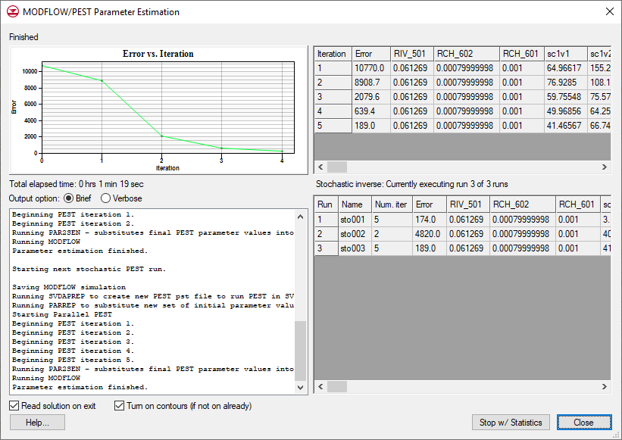

Figure 4 The graph, PEST iterations, runs, and output sections (clockwise from top left) of the MODFLOW/PEST Parameter Estimation dialog

The top left section features a graph that shows the model error vs. PEST iteration. To the right of the graph is a spreadsheet showing the model error and the parameter values for each PEST iteration. Below that, in the bottom right section, is another spreadsheet showing the results for each realization (run) and includes the number of PEST iterations, the model error, and the parameter values. In the bottom left section, a text window shows the output PEST prints to the screen when run from the command line.

There are many steps involved in running PEST with the Null Space Monte Carlo method. GMS runs several PEST utilities to make all of this happen. The following is a list of the steps involved.

1. PEST runs MODFLOW once for each parameter to compute a Jacobian matrix. In this case, there is a steady state model and Parallel PEST is being used, so this step is completed quickly.
2. PPCOV is a PEST utility that generates uncertainty information for the pilot points. The PPCOV utility generates a covariance matrix for the pilot points. This matrix is created using the variogram that is specified as part of the interpolation options for the pilot points. For this reason, kriging must be used with the pilot points if using the Null Space Monte Carlo method.
3. RANDPAR is a PEST utility that generates random values for the parameters that are being randomized, saving one file for each realization. In this example, these files are named “sto000_random1.par”, “sto000_random2.par”, and “sto000_random3.par”.
4. PNULPAR is a PEST utility that modifies the random parameter values through Null Space projection, generating one file for each realization. In this example, these files are named “sto000_random_nul1.par”, “sto000_random_nul2.par”, and “sto000_random_nul3.par”. An explanation of how PNULPAR calculates values is given below:

In this process the difference is first taken between each parameter set and the calibration parameter; this difference is then projected onto the calibration null space, and the projected difference re-added to the calibration parameter set. If the model were linear, and if the cutoff between null and solution spaces were sharp, each new parameter set obtained in this way would calibrate the model with an identical objective function to that achieved using the calibration parameter set. However, in general, random parameter sets modified in this manner do not result in perfectly calibrated models, and will thus require adjustment in order that calibration constraints be respected. Such adjustment takes place through alterations made to the calibration solution space (leaving the null space untouched).[3]

1. SVDAPREP is a PEST utility that creates a new PEST input file (PST) using information from the original PEST run in step 1. PEST then runs SVD-assisted parameter estimation, greatly reducing the number of model runs required for each PEST iteration.
2. For each realization, two steps are required:
3. PARREP is a PEST utility that substitutes the parameter values generated by PNULPAR in step 4 for the current realization.
4. PEST is launched using the parameter values for the current realization and runs until the objective function is at or below PHISTOPTHRESH or until that maximum number of PEST iterations is reached.

The time required for this process can vary depending on the speed of the computer being used. If PEST fails while executing the run, adjust the Parallel PEST wait time to a value of “0.1” (or greater) instead of the default value of “0.001”. This is specified in the PEST dialog accessed by selecting *MODFLOW |* **Parameter Estimation…** in GMS.

## Importing and Viewing the MODFLOW Solutions

Once all the MODFLOW runs are completed, the solutions can be imported. Notice that, for this example, the model error for each of the realizations is less than 200. Each of these new models is calibrated to the same level of error as the original model.

1. Turn on *Read solution on exit* and *Turn on contours (if not on already)*.
2. Click **Close** to close the *MODFLOW/PEST Parameter Estimation* dialog and open the *Reading Stochastic Solutions* dialog.
3. Click **OK** to close the *Reading Stochastic Solutions* dialog and import all converged solutions.
4. Fully expand the new “File:Generic Folder.svg sto (MODFLOW)(STO)” folder in the Project Explorer.
5. View each of the three individual solutions within that folder by selecting each in turn.

Notice how the observation targets change with each solution and that the targets generally remain within acceptable error limits (Figure 5).

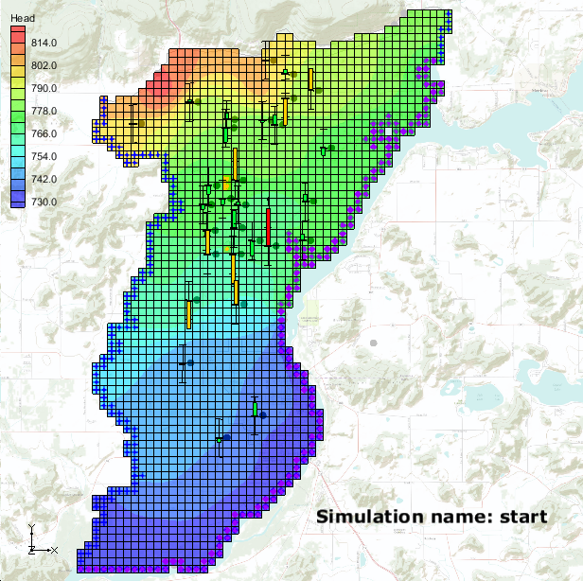 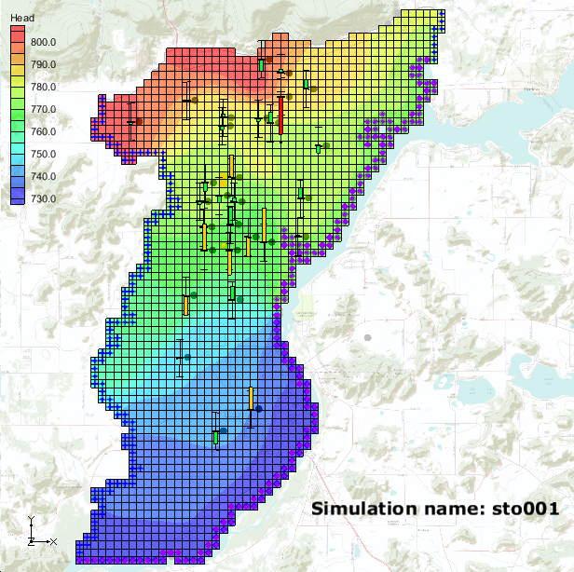

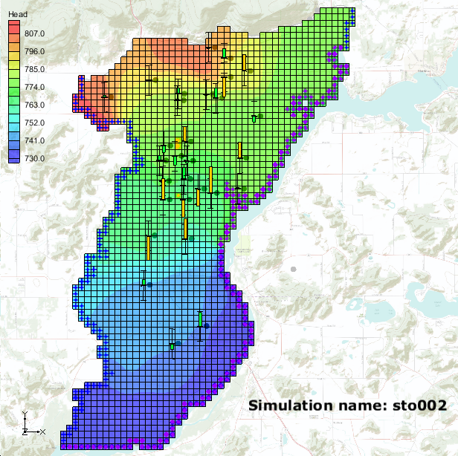 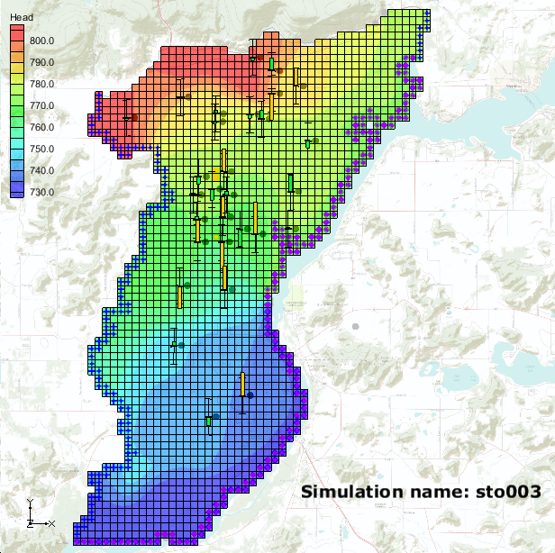

Figure 5 Computed heads from stochastic MODFLOW models

1. Right-click on “File:Generic Folder.svg sto (MODFLOW)(STO)”and select **Statistical Analysis**.

This creates new datasets based on the MODFLOW outputs. Among the new datasets should be “File:Dataset Cells Active.svg mean_Head”, “File:Dataset Cells Active.svg min_Head”, “File:Dataset Cells Active.svg max_Head”, and “File:Dataset Cells Active.svg stdev_Head”.

1. Select “File:Dataset Cells Active.svg stdev_Head”.

The Graphics Window should appear similar to Figure 6. Notice that there is little variability in the computed heads around the locations of the observation points; while in grid cells with no observation points there are standard deviation values up to 6.6.

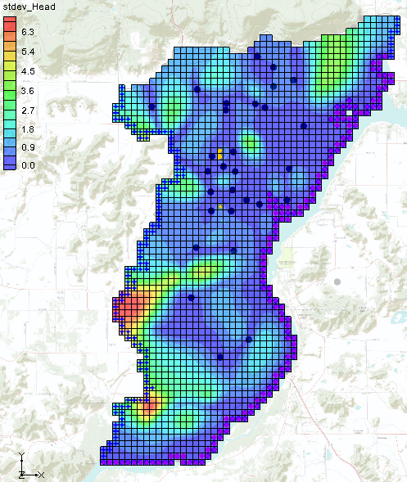

Figure 6 Standard deviation of computed heads from stochastic MODFLOW models

Compare HK datasets to see the different HK fields that will still calibrate the model:

1. In the “File:Generic Folder.svg start (MODFLOW)” folder, under the “File:Generic Folder.svg Parameters” folder, select the “File:Dataset Cells Active.svg HK Parameter -100” dataset.
2. In the “File:Generic Folder Locked.svg sto001 (MODFLOW)” folder, under the “File:Generic Folder.svg Parameters” folder, select the “File:Dataset Cells Active.svg HK Parameter -100” dataset.
3. In the “File:Generic Folder Locked.svg sto002 (MODFLOW)” and “File:Generic Folder Locked.svg sto003 (MODFLOW)” folders, under the “File:Generic Folder.svg Parameters” folder, alternate between the “File:Dataset Cells Active.svg HK Parameter -100” dataset.

Notice the different distribution of HK values (Figure 7).

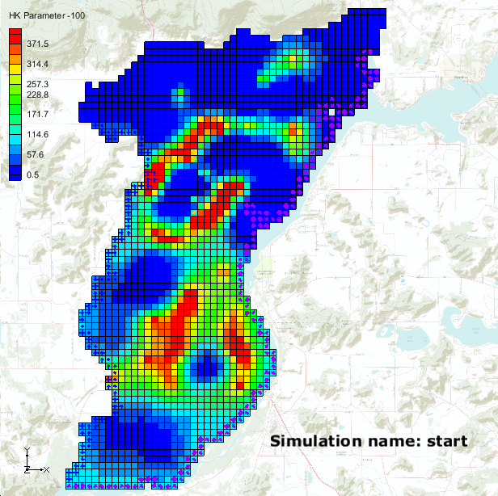 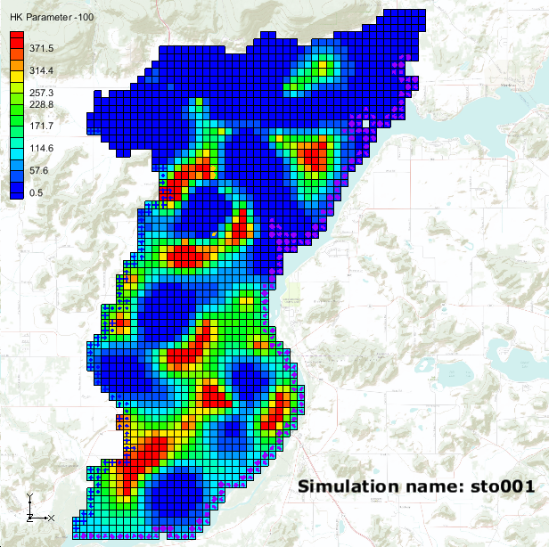

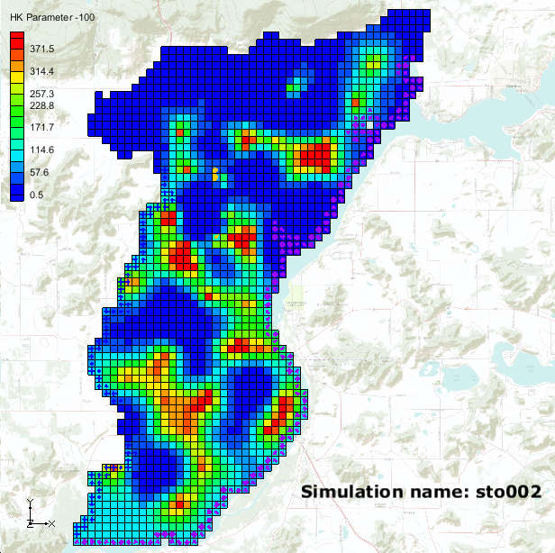 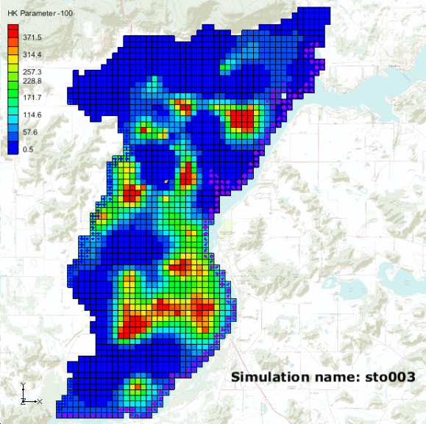

Figure 7 Unique HK fields that calibrate the model

The statistics about the different HK arrays that calibrate the model can be viewed at this point. New datasets were created describing the variability in the HK arrays when executing the **Statistical Analysis** command. Datasets show the minimum, maximum, mean, and standard deviation of HK for each grid cell. View these datasets to get a feel for how much variability can occur in the HK input array and still result in a calibrated model.

1. Under the “File:Generic Folder.svg sto (MODFLOW)(STO)” folder, select the “File:Dataset Cells Active.svg stdev_HK Parameter -100” dataset.
2. Select the “File:Display Theme Icon.svg Head” display theme under the “File:Display Theme Folder.svg Display Themes” folder in the Project Explorer.

The Graphics Window should appear similar to Figure 8. Notice the maximum standard deviation value for HK is around 224.0. This means there are areas in this model where the HK value can vary significantly, and yet the model will still match field-measured head values.

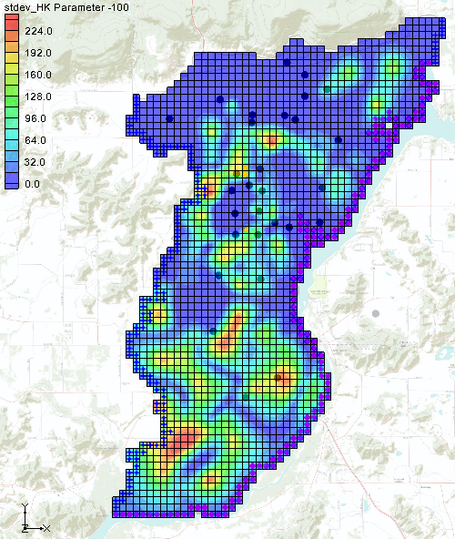

Figure 8 Standard Deviation of HK Input Array

# Conclusion

This concludes the “MODFLOW – Stochastic Modeling, PEST Null Space Monte Carlo I” tutorial. The following key concepts were discussed and demonstrated in this tutorial:

* It is possible to create multiple calibrated models using the PEST Null Space Monte Carlo approach.
* GMS runs several PEST utilities to automate the process of running the Null Space Monte Carlo method.

# Further Reading

—Doherty, J. 2005. *PEST: Model-Independent Parameter Estimation*. Watermark Numerical Computing, Corinda, Australia.

—Doherty, J. 2006. *Addendum to PEST Manual*. Watermark Numerical Computing, Corinda, Australia.

—Moore, C. and Doherty, J. 2005. “The role of the calibration process in reducing model predictive error”. *Water Resources Research*, Vol. 41, No 5. W05050.

—Moore, C. and Doherty, J. 2006. “The cost of uniqueness in groundwater model calibration”. Advances in Water Resources, Vol. 29, Issue 4, April, pp. 605–623.

—Tonkin, M. and Doherty, J. 2005. “A hybrid regularized inversion methodology for highly parameterized models”. *Water Resources Research*, Vol. 41, W10412, doi:10.1029/2005WR003995, 2005.

—Tonkin, M. and Doherty, J. 2007. “Efficient nonlinear predictive error variance for highly parameterized models”. *Water Resources Research*, Vol. 43, W07429, doi:10.1029/2006WR005348.

1. Doherty, John. Date unknown. *PEST Workshop, Regularized Inversion and Predictive Error Variance Analysis*. Watermark Numerical Computing, Corinda, Australia, 66 pages.
2. The null space is comprised of individual parameters, or combinations of parameters, that have no effect on model outputs under calibration conditions. These combinations of parameters can therefore be added to any set of parameters that calibrates the model, thus producing another set of parameters that also calibrates the model.
3. Doherty (Date unknown).